FHIR(Fast Healthcare Interoperability Resources)

Table of Contents
1 FHIR (Fast Healthcare Interoperability Resources) 3
1.1 What is FHIR 3
1.2 Why FHIR 3
1.2.1 Flexibility 3
1.3 FHIR Development Process 4
1.4 Example Resource – Patient 5
1.5 Common Usage 5
1.5.1 Personal Health Record (PHR) 5
1.5.2 Document Sharing (XDS) 6
1.5.3 Decision Support 7
1.5.3.1 Explicit Requests for Decisions 8
1.6 Implementation Checklist 9
1.7 References 9
1.8 Notes from meeting with Thomas and Jack on 03/11/2015 10

FHIR (Fast Healthcare Interoperability Resources)

What is FHIR

FHIR is a next generation standards framework created by HL7. FHIR combines the best features of HL7's Version 2, Version 3 and CDA product lines while leveraging the latest web standards and applying a tight focus on implement-ability.
FHIR solutions are built from a set of modular components called “Resources”. These resources can easily be assembled into working systems that solve real world clinical and administrative problems at a fraction of the price of existing alternatives. FHIR is suitable for use in a wide variety of contexts – mobile phone apps, cloud communications, EHR-based data sharing, server communication in large institutional healthcare providers, and much more.

Why FHIR
- A strong focus on implementation – fast and easy to implement (multiple developers have had simple interfaces working in a single day)
- Multiple implementation libraries, many examples available to kick-start development
- Specification is free for use with no restrictions
- Interoperability out-of-the-box– base resources can be used as is, but can also be adapted for local requirements
- Evolutionary development path from HL7 Version 2 and CDA – standards can co-exist and leverage each other
- Strong foundation in Web standards– XML, JSON, HTTP, Atom, OAuth, etc.
- Support for RESTful architectures and also seamless exchange of information using messages or documents
- Concise and easily understood specifications
- A Human-readable wire format for ease of use by developers
Solid ontology-based analysis with a rigorous formal mapping for correctness

Flexibility

A central challenge for healthcare standards is how to handle variability caused by diverse healthcare processes. Over time, more fields and optionality are added to the specification, gradually adding cost and complexity to the resulting implementations. The alternative is relying on custom extensions, but these create many implementation problems too.

FHIR solves this challenge by defining a simple framework for extending and adapting the existing resources. All systems, no matter how they are developed, can easily read these extensions and extension definitions can be retrieved using the same framework as retrieving other resources.

In addition, each resource carries a human-readable text representation using html as a fallback display option for clinical safety. This is particularly important for complex clinical information where many systems take a simple textual/document based approach.

FHIR Development Process
FHIR is published as a Draft Standard for Trial Use. During the Trial Use phase, HL7 actively monitors implementations in order to continue to improve the specification, and is able to be responsive to their needs. Due to the many advantages FHIR offers, trial use is already beginning right now.
Following this, HL7 will develop FHIR as a full normative specification, most likely through 2015.

Example Resource – Patient
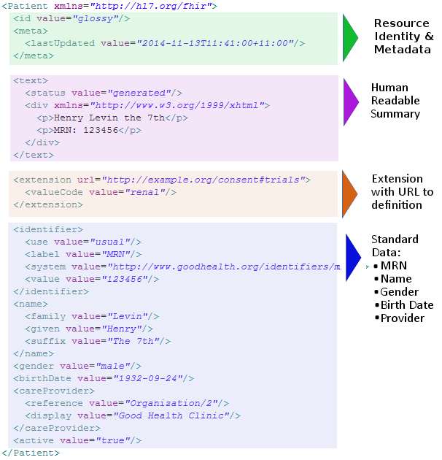

Common Usage
FHIR is a framework standard that defines a common way to solve healthcare problems and provides a set of resources that can be used in many different ways. This page describes how certain common usage scenarios are implemented using the capabilities that FHIR defines. The provided scenarios are examples of usage and are not in any way exhaustive. FHIR can and will be used in a wide variety of circumstances.

Personal Health Record (PHR)
In the PHR scenario, an Electronic Medical Record system (EMR, though many other names and acronyms are also used) provides a RESTful API that allows patients to access their own medical record via a common web portal or mobile application, usually provided by a third party. In this scenario, the PHR provider:
- Provides the patient with a login that identifies them (or links the patient record to an external identity provided by OpenID, Facebook, Google, etc.)
- Authenticates the client using an appropriate OAuth server for the login (possibly their own) and restricts the client to viewing records associated with the specific patient (or patients, where appropriate access has been arranged)
The EMR exposes a FHIR server that supports the search and read operations on the following resources:
- the patient resource in order to provide demographics to the client. When a client searches patients with no search criteria, they get a list of all patients they have access to
- search and read on the Document Reference resource to provide access to general patient documents in the form of PDFs etc. (PDFs are preferred)
- search and read on a set of clinical resources

Here is the conformance Statement for this scenario: XML or JSON.
The EMR may also choose to provide additional functionality, such as shared access to patient records by relatives/carers, to allow the patient to upload their own documents, medication statements, observations (e.g. from patient monitoring devices) and/or to allow the patient to make appointments. This additional functionality will involve additional API capabilities to be implemented and exposed. The EMR server may also choose to expose the search, read and history operation on the Security Event resource for the patient-specific records to allow patient review of record access. Note that all usage of the RESTful API should be logged in SecurityEvent resources.

Document Sharing (XDS)
One common way to integrate healthcare information from a variety of sources is to build a repository of documents around a patient record. Building a repository of documents allows for less stringent alignment around policy, procedures and record-keeping/informatics standards.
The most widely adopted framework for sharing documents within institutions, regions, states or countries is IHE Cross-Enterprise Document Sharing (XDS). XDS allows for a federated system of repositories with a registry to provide coordinated access to the documents.
FHIR provides equivalent functionality to XDS that can be used to implement XDS behind the existing XDS.b interface, to provide a simpler mobile-friendly interface to an existing XDS ecosystem, or to link document sharing into other functionality provided through a FHIR interface.
The following FHIR Resources are involved in the XDS functionality:
- The DocumentReference resource describes a document that is located elsewhere. A document registry is a system that maintains a set of Document References
- The XDS profile provides specific XDS implementation detail for the more general DocumentReference resource
- The Binary support can be used to store the actual documents on a FHIR server. A repository is a system that stores the binary document in addition to Document References (or sometimes without)
- Patient, Practitioner and Organization resources provide support for identifying people and organizations
- The SecurityEvent resource tracks usage of the document registry and repository
- At present, IHE is working with the FHIR project team to use FHIR for Mobile Health Documents (MHD).

Decision Support
One common use of healthcare information systems is to integrate some form of decision support software into clinical systems. Common uses of clinical decision support are:
One common use of healthcare information systems is to integrate some form of decision support software into clinical systems. Common uses of clinical decision support are:
- Drug-drug interaction checking, and more generally, prescription safety checks
- Suggesting commonly missed Diagnostic Data interpretations (including delta checking)
- Patient surveillance for early warning of deteriorating patient health (both acute and ambulatory care)
- Identifying candidates for alternative treatment plans for improved efficacy

Note that in addition to clinical decision support, there are also infrastructural uses, such as managing access control.
The various forms of decision support each involve different interaction patterns, so there is no single decision support implementation in the FHIR specification. Generally, the patterns fall into several classes:
- The decision comes from an engine entirely hidden behind a system interface and has no direct impact on the data excha
- The decision support engine uses existing data and generates alarm messages concerning patient state that are visible on the FHIR interface
- The decision support engine is consulted through a described interface; it accepts a request for a decision and returns a decision

Any decision support may fall into multiple categories at once, depending on the perspective of a particular system.
- There is no particular support required from the FHIR specification, though there will be ongoing review of the contents of the resources to ensure that they support common decision support practices appropriately
- There is no suitable resource for this use yet. The Alert resource is intended or clinical notes about the patient, and is not intended for this use. A resource called "Alarm" is under preparation for this purpose
- A request for a decision support is understood as a search using a named _query that takes a set of parameters. See below

Explicit Requests for Decisions

When a query is initiated in order to get a decision made, the following considerations apply:
Request
- The request for a decision is made using one of the interaction patterns described for search/query: A RESTful search, a query posted to /Mailbox, a query message, or the Asynchronous query pattern
- The request has a _query parameter that identifies the decision that is being requested
- The request also has a set of parameter values. These parameter values may be the data that describes the decision being made or they may be references to specific resources that contain the request. In general, the more complex the decision request is, the more likely it is that a full resource is appropriate, particularly since this provides a ready made way to record and manage the requests themselves.
- In some of the query interaction patterns, the resources identified in the parameter value can be bundled up with the request. In others, only the references can be passed
- Which of the query patterns is most appropriate depends on the complexity of the decision support input, and the length of time the decision is expected to take. As either of these increases, the more complex query patterns become more appropriate

Response
- If the decision support engine is unable to provide the requested decision, it returns an Operation Outcome Resource describing the issue
- Otherwise it returns a resource that represents the decision, along with other resources as supporting information, as described by the resource, or applicable profiles
- In principle, the decision provider can choose to make a copy of the returned decision resource available through a normal RESTful interface, or it can choose not to. This decision may be constrained by applicable profiles, policy decision, or the innate nature of the query
- If either the decision provider or the requester choose to retain a copy of the decision, they must ensure that the (lack of) currency of the decision is appropriately considered when it is used

It follows from this then, that decisions that may be requested need at least a response resource defined, and possibly a request resource. This table summarizes known decisions for which resources have been defined.
Decision | Resources | Invocation
What immunizations should this patient have? | Response: ImmunizationRecommendation | The exact way to invoke this decision is not yet defined
Implementers are allowed to use existing resources for decisions not documented here, but there is no guarantee that they will be suitable. Improving decision support will be a focus for ongoing development during the Trial Use period.

Implementation Checklist

This section is a check list to help implementers be sure that they've considered all the parts of FHIR that impact on their system design with regard to safety.
- Production exchange of patient or other sensitive data will always use some form of encryption on the wire
- For each resource that my system handles, I've reviewed the Modifier elements
- My system checks for modifierExtension elements
- My system supports elements labelled as "must-support" in the Profiles that apply to my system
- My system can render narratives properly (if/when they are used)
- My system has documented how distributed resource identification works in its relevant contexts of use
- My system uses the right security labels where appropriate
- When other systems return http errors from the RESTful API or from the Mailbox (perhaps using Operation Outcome), my system checks for them and handles them appropriately
- My system publishes a conformance statement so other implementers know what it does
Obviously this list is only a small part of the overall safety check list for an application, which will have checks regarding jurisdictionally mandated policies, internal integrity, etc.

References

- http://www.hl7.org

Notes from meeting with Thomas and Jack on 03/11/2015

- Add scope/Biz goals
- How it is/will be used
- Is there a reference implementation
- Description/Artifacts (code/design docs/spec/is it RIM based)
- Effect on GDIT and customers

VA EHRM Alpha Sites
The following list names the VA Medical Centers for rollouts, pre-site readiness reviews for VA EHRM integration readiness assessments and tasks.
- Cincinnati VAMC-Fort Thomas (Fort Thomas, KY)
- Chillicothe VAMC (Chillicothe, OH)
- Cincinnati VAMC (Cincinnati, OH)
- Dayton VAMC (Dayton, OH)
- Louis Stokes Cleveland VAMC (Cleveland, OH)
- Fort Wayne VAMC (Fort Wayne, IN)
- Marion VAMC (Marion, IN)
- Richard L. Roudebush VAMC (Indianapolis, IN)
- Alaska VA Healthcare System (Anchorage, AK)

